Week 2
In week 2 we moved on to trying to configure the sensors and the connection between the m5 stack, the EVN III and earth monitor. This is to extract out data for us to process into AWS. For this week we are focusing more on ensuring a strong connection for the m5 stack core 2 as well as to integrate it into the AWS.
Sensor connection process:
1) to connect the sensors we first tested out with the sounds made from each port when connected to a sensor, this is to ensure there is current running through the device and the sensors are able to show some value.
2) Using the extension unit provided we connected the port c, while using the ENV III and connecting it to the grove hub (the extender) while the earth monitor is in the b port

Things done so far this week we have tried to make the code for our sensor connection.
A couple of things we have integrated into our code would be the imports of the m5stack, m5 ui and ui flow this is the librarys we originally placed to go ahead with, for time stamps we also added a time sensor for handing delays

For the sesonrs we also needed to identify the gpio pins and where they should be connected after doing some finding we realised that the port for this sensor is port b due to the gpio of the device being gpio 39 allowing there to be input and output of data. This was also managed by the calibration_min and max ( to see the ensors specifics to map raw

Weekly Report: Week 2

Objective
In Week 2, our primary focus was on configuring the sensors and establishing robust connections between the M5Stack Core2, EVN III, and the Earth Monitor. The goal is to extract data efficiently for processing within AWS. This week, we concentrated on ensuring a stable connection for the M5Stack Core2 and integrating it seamlessly with AWS.

Sensor Connection Process
- Initial Testing:
  - Port Sound Verification: We began by connecting each sensor to different ports and listening for distinct sounds. This method confirmed the presence of current flow through the device and validated that the sensors were capable of generating measurable values.
- Port Configuration:
  - Extension Unit Utilization: Using the provided extension unit, we connected Port C to the EVN III and the Grove Hub (extender), while the Earth Monitor was connected to Port B.

Achievements This Week
- Code Development for Sensor Integration:
  - Library Imports: Integrated essential libraries including m5stack, m5ui, and uiflow to support M5Stack devices. Additionally, imported the time module for handling delays.
  - Timestamp Implementation: Added a time sensor to manage delays effectively.
- GPIO Pin Identification and Configuration:
  - Pin Mapping: Identified that Port B (GPIO39) is suitable for our sensor due to its capability for both input and output operations.
  - Calibration Parameters: Managed sensor specifics by setting CALIBRATION_MIN and CALIBRATION_MAX to map raw ADC values accurately.

Technical Implementation
- Imports and Initialization:
  - Libraries:
    - m5stack, m5ui, uiflow: For M5Stack device operations.
    - time: To handle delays.
  - Sensor Configuration:
    - SENSOR_PIN: Configured to GPIO39 (Port B) for analog input.
    - CALIBRATION_MIN & CALIBRATION_MAX: Set based on sensor specifications to translate raw ADC values into meaningful data.
- Sensor Data Handling:
  - Reading Sensor Data:
    - read_sensor(pin): Captures the raw analogy value, normalizes it, and handles exceptions.
    - average_readings(pin, num_samples, delay_ms): Averages multiple readings to minimize noise and enhance reliability.
  - Main Loop Operations:
    - Continuously reads and averages sensor data, converts it to a percentage, and displays it on both the M5Stack Core2 screen and the serial monitor.
    - Implements error handling to display messages if sensor data retrieval fails.
- Code Deployment:
  - Uploading the Code:
    - Copied the MicroPython script into the UIFlow MicroPython editor.
    - Uploaded the script to the M5Stack Core2 using the “Upload” or “Run” button.
  - Monitoring Outputs:
    - Observed real-time sensor readings on the M5Stack Core2’s screen.
    - Utilized the serial monitor in UIFlow for debugging and monitoring.

Best Practices for Reliable Data
- Calibration:
  - Ensured CALIBRATION_MIN and CALIBRATION_MAX are accurately set based on sensor specifications. Performed calibration routines to determine precise values.
- Stabilizing Readings:
  - Averaging: Employed multiple samples and averaged them to reduce transient noise.
  - Delays: Implemented appropriate delays between readings to allow sensor stabilization.
- Error Handling:
  - Incorporated try-except blocks to manage exceptions during sensor readings, preventing unexpected program crashes.
- Power Supply Stability:
  - Verified that sensors receive a stable power supply to avoid voltage fluctuations that could lead to unreliable readings.

Troubleshooting
- No Data Displayed:
  - Verified the physical connections between the Earth Monitor sensor and Port B.
  - Ensured SENSOR_PIN is correctly set to GPIO39, appropriate for analog input.
- Erratic Readings:
  - Checked for electrical noise in the setup and considered adding capacitors if necessary.
  - Confirmed proper sensor calibration.
- Sensor Not Responding:
  - Verified sensor compatibility with the M5Stack Core2.
  - Checked if the sensor requires specific initialization commands as per the sensor’s datasheet.

Additional Enhancements
- Data Logging:
  - Planned modifications to log data to an SD card or transmit it to a cloud service for long-term monitoring.
- Alerts:
  - Implemented threshold-based alerts to notify when sensor readings exceed acceptable limits.
- User Interface Improvements:
  - Enhanced the display by adding graphs and more detailed information on the M5Stack Core2’s screen.

GPIO Mapping for M5Stack Core2 Grove Ports
Grove Port | GPIO Pin | ADC Channel | Notes
Port A | GPIO35 | ADC1_CH7 | Input-only, no internal pull-up/down resistors
Port B | GPIO39 | ADC1_CH3 | Input-only, no internal pull-up/down resistors
Port C | GPIO34 | ADC1_CH6 | Input-only, no internal pull-up/down resistors
Port D | GPIO36 | ADC1_CH0 | Input-only, no internal pull-up/down resistors
Characteristics of GPIO36:
- Input-Only Pin: Cannot be used for output operations.
- No Internal Pull-up/down Resistors: External biasing required if the sensor needs it.
- Voltage Range: Supports 0-3.3V to prevent GPIO damage.
- ADC Resolution: Provides up to 12-bit resolution (0-4095). Calibration may be necessary for accurate data mapping.

Sensor Data Validation
- Raw Value Analysis:
  - Tabulated and compared raw ADC values based on research to ensure accuracy.
  - Determined raw ADC values for humidity and temperature, applying a scaling function for quality results.
- Temperature Calculation:
  - Adopted the formula: Temperature=m×Raw ADC Value+b\text{Temperature} = m \times \text{Raw ADC Value} + bTemperature=m×Raw ADC Value+b
  - Calculations:
    - Slope (m): m=40−202500−1500=201000=0.02°C/ADC unitm = \frac{40 - 20}{2500 - 1500} = \frac{20}{1000} = 0.02 \degree C/\text{ADC unit}m=2500−150040−20​=100020​=0.02°C/ADC unit
    - Intercept (b): 20=0.02×1500+b20=30+bb=−1020 = 0.02 \times 1500 + b \\ 20 = 30 + b \\ b = -1020=0.02×1500+b20=30+bb=−10
    - Observed Raw ADC Values:
      - At 25°C: Raw ADC ≈ 1500
      - At 30°C: Raw ADC ≈ 1800
      - At 35°C: Raw ADC ≈ 2100
    - Slope Determination: m=30−251800−1500=5300≈0.0167°C/ADC unitm = \frac{30 - 25}{1800 - 1500} = \frac{5}{300} \approx 0.0167 \degree C/\text{ADC unit}m=1800−150030−25​=3005​≈0.0167°C/ADC unit

Wi-Fi Connection and Configuration for M5Stack Core2
- Power On the M5Stack Core2:
  - Turn on the M5Stack Core2 and press the UI Flow button. A prompt will appear, asking you to choose between USB and Wi-Fi.
- Select Wi-Fi Mode:
  - Choose the Wi-Fi option. The M5Stack Core2 will reboot and display a page with an SSID and IP address.
- Connect to SSID:
  - On your computer, connect to the M5Stack’s SSID (displayed on the device screen). Ensure you are using a browser that is not restricted by a firewall.
- Access the Wi-Fi Configuration Page:
  - Open the browser and enter the IP address provided by the M5Stack Core2. This will direct you to the Wi-Fi configuration page.
- Enter Wi-Fi Credentials:
  - Input the desired Wi-Fi network credentials. In this case, connect to your personal hotspot “Rachel” by entering the correct password, then press Configure.
- Reboot and Apply Settings:
  - The M5Stack Core2 will reboot to apply the new Wi-Fi settings.
- API Key Display:
  - Once rebooted, the device will display an API key, which is essential for connecting with UIFlow or any other integrated services.

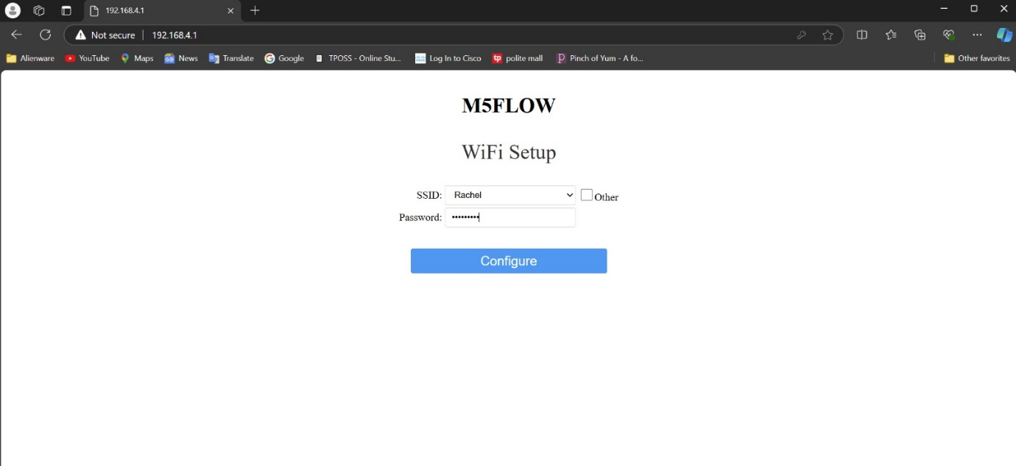
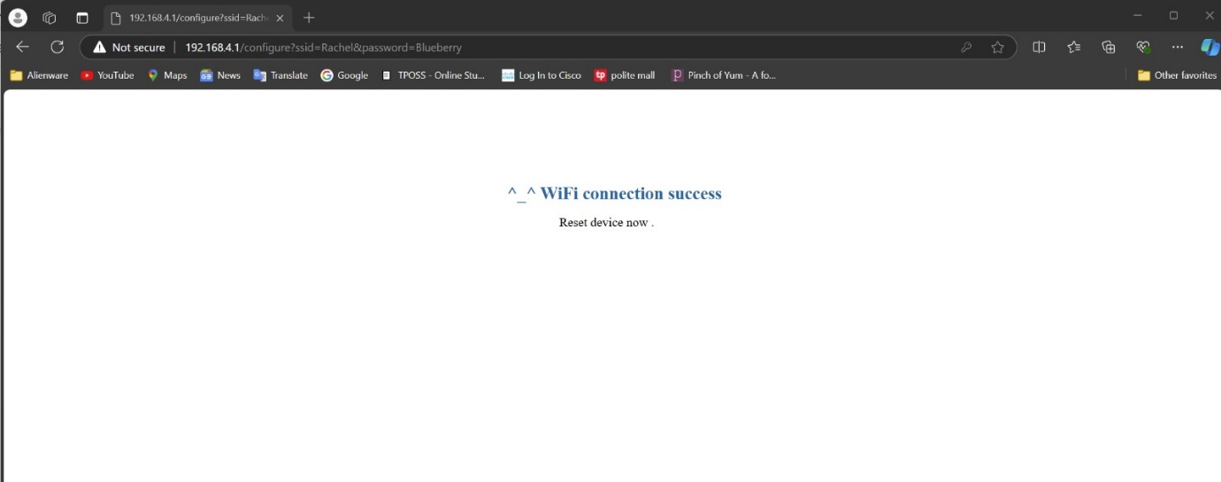
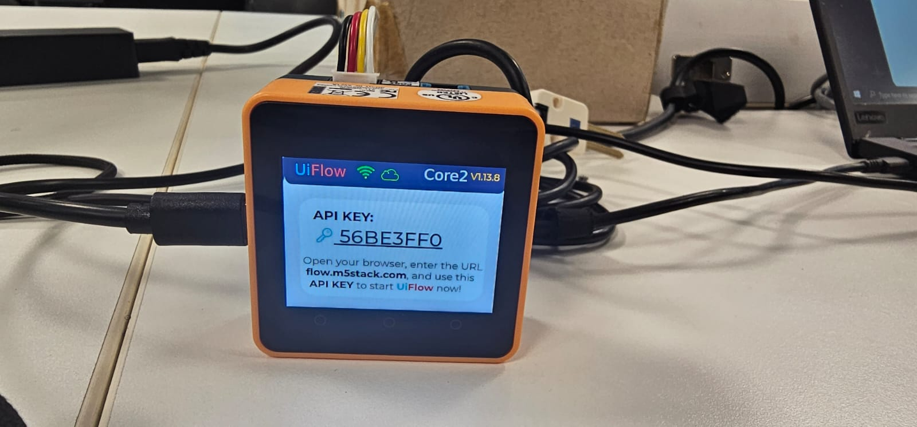

MQTT configurations:
This process was done in AWS IoT Core module, where we need to connect the M5 Stack Device to the cloud services in AWS. We begin by creating the policy to later be implemented in a “Thing” in AWS IoT, which would be connected to the M5 Stack. However, before finalizing the creation of the policy. I had to download the files of the Private Key and Certificate for that policy to establish the connection. Which was stored in the file explorer as well as in the m5 stacks file also known as the “/flash/”.
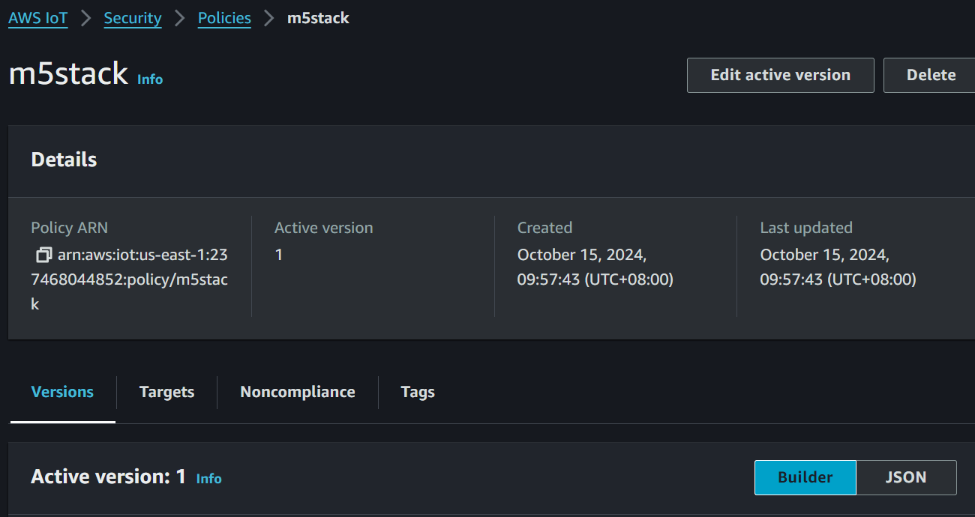
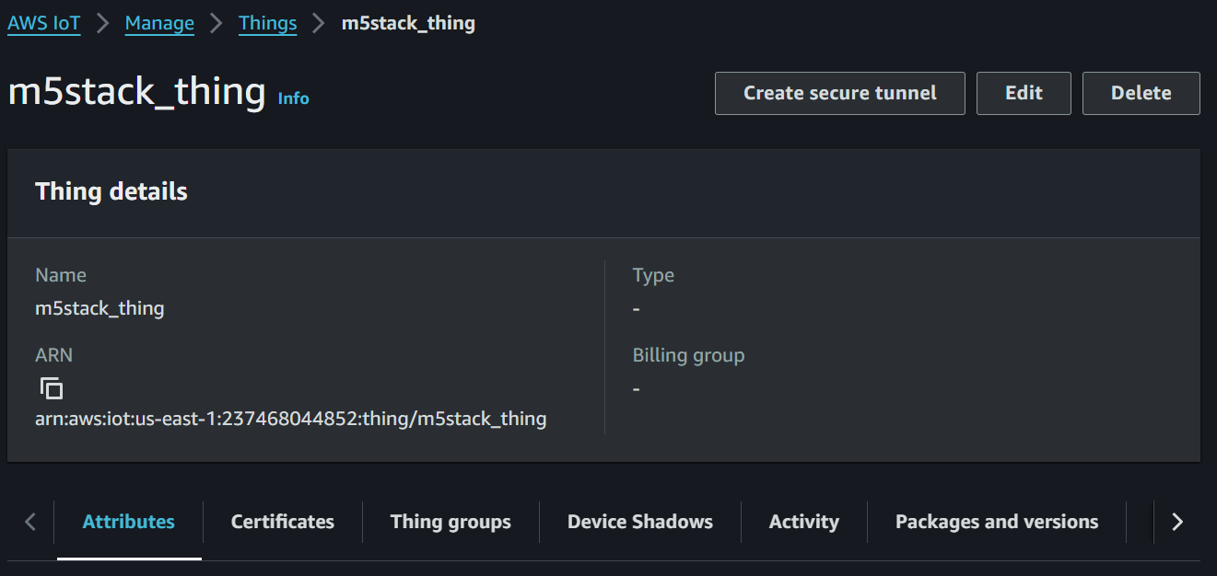
Once the configuration in AWS is done, we moved on to the Ui Flow version 1.13.8 where we used Blocky to do up the M5 Stack Device’s side of connection. As shown in the image bellow:

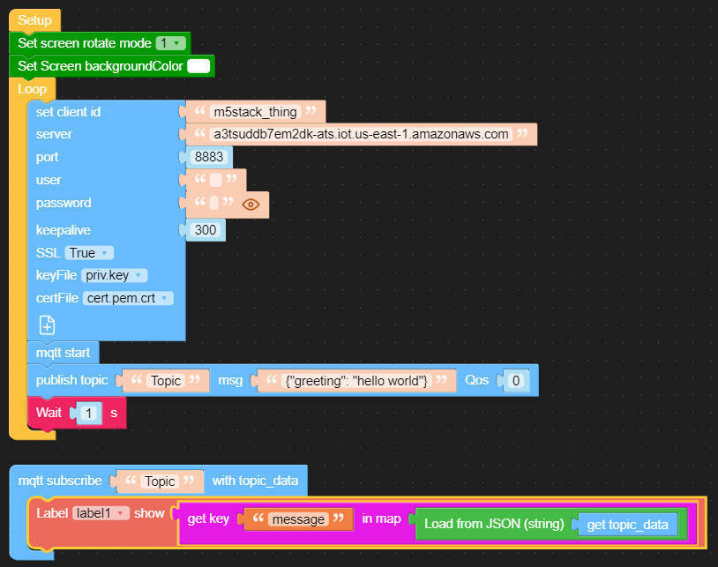
The connection was established half successfully as the connection from the M5 Stack Device to AWS IoT was successful, as per screenshot of the Subscription’s publish. However, from the receiving end it was unable to print out the desired results, from AWS IoT to the M5 Stack device.

